# On Guard 3.0

## What is This For/What Does it Do?

IP (WiFi and Ethernet) security cameras are getting more and more capable. Detecting motion is one of the most useful features for such cameras. However, the consumer grade cameras are not particularly good at sifting important movement from “junk” movement. Further, movement of a specific type (people walking) may be important in one area and uninteresting in other areas. Also, it can also be important to know the difference between motion caused by moving cars, or moving people. In these cases, AI (Artificial Intelligence) can be very useful in identifying the type of movement. Getting free software that accomplishes these goals is now possible.

On Guard provides an engine and user interface that takes **still** (.jpg) images from a video source and processes them through an Artificial Intelligence application called **DeepStack**. DeepStack identifies the object types (people/cars/trucks/animals) and gives back a list of objects it has found. On Guard takes the location of objects in video snapshots identified by the AI application and further analyzes them for importance, location, and size. It provides the ability for the user to delineate areas of interest, and the type of objects that are of interest within an area. It can optionally trigger an external application (Blue Iris, etc.) to start recording a video. It can also optionally send an email notification to the user that important motion has been detected. It can notify smart devices such as light switches via an HTTP message or MQTT.

## What Doesn’t it Do?

On Guard does not store video. However, it can be used to trigger the storage of video captured by other applications via a message sent to the service providing video storage. Why? In large part this is due to limitations in developer time. This **may** change in the future. However, capturing still images is still very useful for security purposes. Often the still images are of higher quality than individual frames in videos. Further, these images can **much** more easily be shared with other people (including police departments). They can also be sent via email and MMS messages with minimal overhead.

## What Cameras/PCs Are Compatible?

On Guard will work with almost any “IP” camera. However, it will **not** work with cameras that are “locked into” a “closed ecosystem”. What this means is that many cameras are deliberately designed/restricted so that they will only work with the vendor’s proprietary software/hardware. This includes many (but not all) doorbell style cameras. If the ad for your camera says that it is ONVIF, Blue Iris, or iSpy compatible it will almost always work with On Guard. That said, there are literally hundreds of brands of cameras, and there is no way that On Guard could be tested with even 1% of these cameras. If you want to provide the camera it can be tested….

Note that this application only supports computers running a 64-bit version of Windows. There are good technical reasons for this. However, if you wish to use the application on 32-bit version of Windows please request this. It may be possible. A minimum of 8GB RAM is required for all practical purposes (more so for DeepStack than OnGuard).

On Guard should be usable on almost all PC displays. However, the tool used for On Guard development is not particularly good at laying out text for “high DPI” (dots per inch) displays. Often users with high resolution displays (for example 3200x1800) will scale up size of text to make it more readable. Please look at the Windows Settings/Display/Scale and Layout menu. There you may see the option “Change size of text, apps, and other items”. Depending on your scale setting there On Guard may or may not layout all text properly. For instance, labels may be cut off, etc. There isn’t a good fix for this other than to completely rework On Guard using a more modern development tool. While this may happen, it would be a very, very time-consuming task. On Guard has been tested on different displays and with different scaling factors, but there are no guarantees. While things may not be perfect on your display, they should be “good enough” to be useable and useful.

## What is the DeepStack AI, and how do I install it?

The DeepStack AI (<https://www.deepstack.cc/>) is used as the engine for identifying objects within the pictures provided by your camera. DeepStack is run as a separate application on a PC or Linux computer. DeepStack is an AI can identify a number of objects that we care about in a security camera as well as a number we don’t care about. What we do care about are typically people, vehicles, and perhaps animals.

There is an automatic installer for Windows or it can be installed on a Linux computer. The installer can be found at the location in that link. The installation of the DeepStack CPU version is automated and quite easy. The installation of the GPU version (more on that later) does require that you install “driver” software from NVidia (it is called CUDA). Instructions are available on the DeepStack web site.

On Guard can automatically start and stop DeepStack (on Windows) once you have installed it. It can automatically set the correct options. It also ensures that DeepStack is running. If DeepStack stops responding On Guard can restart it.

## Is My Private Information Sent over the Internet?

The short answer is **no.**  However, information (often including passwords) is sent from your camera to On Guard, and from On Guard to DeepStack. That information is **not** encrypted. Note that no information is **ever** sent over the Internet unless it is between devices that **you** locate remotely. You may or may not decide to send your alerts and pictures via email and/or MMS (SMS messages). These notifications do involve Internet traffic, but don’t typically contain private information.

There are camera user names and passwords stored in the On Guard settings file, and that information is not currently encrypted. Don’t use your PC user names and passwords for your cameras!

## What Does This Cost?

On Guard itself is free for personal and small business use. DeepStack is free for personal use. See their website for any restrictions. There are no support fees of any kind.

The other cost to consider is the cost of having a reasonably capable Windows PC working 24/7. It is suggested that you use a computer with at least 4 cores and at **least** 8GB RAM. Adequate hard drive space is also necessary. Running the AI software can consume minimally more electricity than a standby PC since the AI process is CPU/processing power intensive, but ideally picture events happen relatively rarely except in very busy areas.

Reasonable quality IP cameras can be purchased for between $100 to $500++ per camera. HD cameras are definitely a good idea, but they aren’t required. You can use as many cameras as you wish. A camera capable of Pan/Tilt/Zoom is very useful and strongly suggested for most applications.

Note that On Guard has **not** been tried on doorbell style cameras. It almost certainly will **not** work with the Ring camera. It might work with the Nest doorbell camera. It will very probably work with the DoorBird doorbell camera, but this has not been tested. If you are purchasing a doorbell camera look for those that support ONVIF, HTTP, Blue Iris, or iSpy.

## Live vs. Stored Pictures

The Artificial Intelligence (AI) utility used by On Guard (DeepStack) has two distinct operating modes. The first mode, CPU (Central Processing Unit), can be used with almost any computer. However, it can be quite slow. Analyzing an individual picture could take less than 1 to 10+ seconds depending on your computer speed. Obviously, this isn’t suitable for analyzing each picture in a live/real time video from your camera. Thus, there needs to be some pre-processing done via your camera or third-party camera software to weed out pictures without motion. The camera/software must then store a picture it thinks has motion in it on your local computer drive. On Guard can process that picture.

In the second mode, GPU (Graphics Processing Unit) and a compatible **NVidia** graphics card in your computer you the DeepStack AI may be able to fully analyze 1 – 10 pictures **each** second. Thus, the AI **can** do real-time processing of images. In this mode there is no need to store all potential motion pictures to your computer disk.

On Guard 3.0 can now use either method. It will recognize pictures stored to your disk in the CPU mode, and it can fully analyze live pictures directly from your camera in GPU mode. In the GPU mode pictures will only be stored to disk if they have real/analyzed motion in them!

The GPU mode does require an **NVidia** based graphics card of a reasonably recent vintage (must support CUDA). Most desktop computers use (1) the graphics capability of the main computer board – no separate graphics card (2) an NVidia based GPU graphics card or (3) an AMD GPU based graphics card. Note that NVidia and AMD (Raedon) based cards are be sold by many different manufacturers. For instance, your graphics card may be made by Gigabyte but feature an NVidia GPU. While AMD cards are very capable, they just aren’t supported by the AI used by On Guard. If you have no graphics card or an AMD based graphics card you will be stuck with the CPU mode.

## Dependencies

On Guard has been extensively tested using Blue Iris (<https://blueirissoftware.com/>), ONVIF, iSpy camera definitions, HTTP and FTP as a source for motion images. You can choose the input source for each camera. By choosing the appropriate input method you should be able to use On Guard for more than 90% of IP camera makes and models with the exception of many doorbell cameras.

### Blue Iris

Blue Iris is a very capable Windows PC application for managing security cameras and recording videos from those cameras. Blue Iris has a built-in capability for detecting motion, and some capability of detecting objects. Blue Iris itself can also be setup to use DeepStack for analyzing pictures. Blue Iris provides an important service in looking for motion in the cameras it monitors. Blue Iris does need to be setup properly to provide this service. Blue Iris can be setup to start recording video when On Guard triggers it.

### ONVIF

ONVIF is a protocol (language) for getting images from a camera in addition to providing camera Pan/Tilt/Zoom for cameras that support it. ONVIF is becoming a standard feature for almost all IP (WiFi/Ethernet) cameras. You should easily be able to find out if your camera supports ONVIF by looking at your camera product website. On Guard fully supports ONVIF for getting still images, Pan/Tilt/Zoom and camera preset positions.

### HTTP

For cameras that don’t support ONVIF (or ONVIF doesn’t provide the features you want) you can use HTTP (web request) messages. The great majority of cameras in use today support taking pictures, PTZ, and presets using HTTP. In general, using standalone (raw) HTTP messages can **quite** difficult. However, there is a great shortcut available – iSpy HTTP definitions.

### iSpy

iSpy is an application used for monitoring security cameras. While iSpy can be used as an alternative to On Guard, On Guard does have features that iSpy doesn’t. Nevertheless, iSpy just happens to have a great set of pre-defined HTTP messages that will support the large majority of cameras for the purposes of taking snapshot pictures, controlling PTZ, and preset support. On Guard can uses these definition files to make the process of sending control messages to your camera very, very painless! All you need to do is select your camera make and model! You can even bypass that step by using On Guard’s “Auto Find” button and wait a minute or two! That said, the automatic find feature only provide commands for snapshot/still image support. While the found camera make/model for snapshots will often work for PTZ and presets, this isn’t always the case. In general, using the iSpy method is quite easy.

### FTP (File Transfer Protocol)

FTP is a protocol/language that allows files to be transferred between cameras and computers. In our case the files we care about are still .jpg pictures. Most cameras will support the option of sending an FTP message to your computer when it detects motion. However, your computer does need to be setup to receive these messages. While this initially appears to be a significant technical challenge, it can be very useful. By using FTP you can make your camera do a lot of the initial work in detecting motion. More and more cameras are supporting some form of AI in their hardware so they can weed out uninteresting pictures. This can be a big help in minimalizing the computing load for On Guard and DeepStack.

One limitation the using FTP is that the FTP settings for your camera may be quite limited. While every tested FTP camera supports sending at least one picture, it may not allow you to send pictures at an interval you want for as long as you want. Thus, On Guard uses incoming FTP messages as a trigger. On Guard will then request that the camera send you additional live pictures for the time period you decide upon.

## How On Guard Works

On Guard works in distinct phases. The exact steps are dependent on your camera and your settings. Here are some scenarios On Guard supports:

#### Software Scenario

1. You are monitoring your camera using software from Blue Iris or similar software.
2. That software detects gross level movement.
3. Your software starts taking pictures and stores them to disk.
4. On Guard recognizes that there is a new picture in the software output directory.
5. On Guard sends the picture to DeepStack.
6. DeepStack responds with a list of objects in the picture.
7. On Guard looks at the objects and decides if these objects are “interesting”.
8. On Guard sends an email notification, requests that your monitoring software record video, sends an email, sends an MMS message to your phone (or any combination of these actions).

#### Direct Monitoring Scenario (NVidia GPU Strongly Preferred)

1. On Guard requests that the camera provide a live picture at an interval you set.
2. On Guard sends the picture to DeepStack for analysis
3. DeepStack responds with the object list.
4. On Guard analyzes the response and further processes it.
5. If there is interesting activity On Guard stores the picture and optionally notifies recipients as above.

#### FTP Triggered Scenario

1. The camera uses its own hardware to detect motion.
2. The camera sends the picture with motion to the monitoring computer using FTP.
3. On Guard, running on the monitoring computer detects the new picture in the FTP destination folder.
4. On Guard analyzes the picture via DeepStack.
5. If there are interesting objects in the picture On Guard will request live pictures from the camera.
6. On Guard stores the original and requested/live pictures from the camera on the hard disk.
7. On Guard analyzes the pictures to see if anything else interesting is happening.
8. On Guard performs notifications as above.

## What your security camera sees may be important (or not).

For security camera purposes we primarily care about people and vehicles, but animals (dogs, cats, etc.) may be considered important to you as well. On Guard allows you to define what you consider important, and in which areas they are important. For instance, cars driving down the street or people walking down the sidewalk are probably not too interesting. However, if a car pulls into your driveway, or if people walk up to your front door, then that event may be quite interesting.

On Guard allows you to define one or more Areas of Interest (or zones as they are often called). Within each area you define if you care about people, cars, trucks, etc. You define what degree of confidence the AI has that the object it finds has been identified correctly. You define what percentage of an object must be within an area. You define the minimum size required for an object within the area.

## What happens when interesting motion is detected

You decide if you want to be notified by email, or if you want you can send a message to any web address (URL)/web service. Blue Iris has the capability to begin taking videos on the basis of that web site notification (even/preferably if the “web site” is on your local PC). On Guard also allows you to notify smart home devices to start taking some action (turn on lights, etc.) via IFTTT.com (If This Then That). IFTTT is widely support and can be very powerful (turns on lights, etc.), but it there is a learning curve. You can also decide if you want to just ignore certain objects in certain areas (for example cars are important in your driveway but not the street). You can also use MQTT to notify you or your devices when movement is discovered.

## Getting Started

Download the .zip file from Github at: https://github.com/Ken98045/On-Guard.git. Usually you want to use the latest “Release” version. Extract the directory On-Guard-master. Open the Setup directory and run the Setup.exe program. If all goes well the application will start and the initial setup steps will be started.

On Guard supports multiple cameras. However, for now choose just one camera and get it working. After setting up one camera the others should come easily.

You will need to know/provide the following information:

1. The folder where pictures are stored by your software and/or where you want interesting pictures stored.

2. Each picture taken or stored on your computer must have a set “prefix”. This is the fixed part of the picture file name. This is often the camera name. Typically, a code representing the date/time of the picture is then added to this prefix. An example is: **aiFront**.20200726_142218821.jpg where **aiFront** is the prefix.

3. The IP address and port of your camera or software or software.

4. The user name and password of the camera/software.

5. Your outgoing email server name and port (if you want to use email notifications).

6. The IP address and port of DeepStack. However, if DeepStack is on the On Guard computer you can just use On Guard to manage this.

7. How you are going to contact the camera (Blue Iris, ONVIF, iSpy, etc.).

While this may sound like a lot of setting (well, yes, it is a lot) there is not much we can do about that. Presumably if you knew enough to find this application, you know enough to find all of that information without too much difficulty

## Running On Guard

### Initial Setup

The first time you run On Guard you will receive a popup message directing you to set some setting values. There several settings pages you will need to fill in. After running for the first time the settings will be saved. There are “Help” buttons on many of the settings screens.

#### Step By Step On Guard

1. Install DeepStack from (<https://www.deepstack.cc/>). Make sure that DeepStack runs either from a Windows command prompt or the Windows start menu. Alternatively, you can run DeepStack from a Linux computer. However, if you do run DeepStack on Linux On Guard can’t automatically manage it.
2. Define the data/settings storage folder location for On Guard. Normally you can just use the default settings.
3. Decide whether you want On Guard to manage the start/stop/restart of DeepStack. Normally you do want this so you can use the defaults settings. Don’t forget to start DeepStack (green button) and test the connection (red button). Usually, the default settings work fine.
4. Review/Set the SQL connection string. Unless you are an advanced user use the default settings.
5. Decide the default application for viewing the On Guard log file. Normally you can use the default setting of Notepad.exe.
6. Add a camera. Since this is a bit complicated it will be discussed separately.
7. Setup your outgoing email server. This allows you to send yourself emails (and MMS/SMS) messages when interesting motion happens. You may need to lookup these settings for your Internet provider on their web site or search the Internet for the appropriate settings. For example, Comcast uses: “smtp.comcast.net”.
8. Add one or more email addresses for mail notifications.
9. **If** you are using Blue Iris you will need to setup that application to “feed” On Guard motion pictures. The setup steps are located in an Appendix.

#### Adding a Camera

1. When you start adding a camera you will see (from the Tools/Camera Settings menu or the initial setup sequence) a dialog box/window with several tabs. The **first** thing to need to do is press the “Add Camera” button.
2. Once you press the Add Camera button another dialog/window will appear, also with multiple tabs on it. This is the “Add/Edit Camera” window.
3. The Add/Edit window defines how On Guard will interact with the camera. You have 3 main choices (1) Application Filtered (2) On Guard Image Scan (3) Camera Triggered (FTP). If you are using Blue Iris, iSpy, or another application to filter pictures for motion and “feed” On Guard just leave it with the default option (1). If you want On Guard to actively request pictures from your camera, choose the second option (2). If you want the camera hardware to identify motion and notify you via FTP choose that option. Note that options (1) and (2) are the easiest to setup.
4. In all three cases you will need to use the second tab (Location) to specify where pictures with motion are placed, or should be placed by On Guard. You will also need to enter the picture name prefix. This is the start of the picture file name. Press the “Help” button on that tab for more information.
5. What comes next depends on your choice in step 3. If you want On Guard to request images from the camera select the “On Guard Scan” tab. If you chose the Camera Triggered option, click on that tab. If you are using Blue Iris or another application to check for motion you are done.
6. Click OK. You will then go back to the Camera Configuration window. Now comes the harder part.
7. Click on the Camera Address tab. There are further directions (and a Help button) on this tab. You must fill out the required IP Address and Port for the camera as well as the camera (or application) user name and password. If you are using Blue Iris on your current computer, you can use the default value of “localhost”. If not, you will need the camera address. You can usually find that using the camera application(s) provided by your camera vendor if you don’t know it. The camera Port is usually the default value of 80. The ONVIF port varies by camera. Your camera software will either include this information or you can attach to your camera using a browser and find (or set) it there. If your camera does not support ONVIF, just leave it with the default value and it will be ignored.
8. Click on the Snapshot/Live tab. There are further directions and a Help button there as well. The most important decision is what method you are using to get snapshot pictures from the camera and into On Guard. In this case Blue Iris is the easiest option since it only requires the camera “short” name as a part of the setup. ONVIF is quite simple as well. The iSpy option just requires your camera make and model (or use the “Auto Find” button). The HTTP method requires the most technical expertise, but does offer the most flexibility.
9. If your camera supports Pan/Tilt/Zoom you must go on to the PTZ and Presets tabs. Directions are there with a Help button too. Note that most other camera applications do not allow you to mix and match Snapshot, PTZ, and Preset methods. On Guard does allow this, but you normally want to be consistent and use the same method for each. On Guard allows more flexibility, but adds slightly more configuration. That configuration is normally just a matter of a click or four.
10. The last tab, “Other Options” is just that. You can decide if you want to monitor sub-directories (folders). You can decide the camera timeout that decides when motion has stopped. You can also tell the camera to go to preset positions at specific times or times of day. For now, it is suggested that you leave these settings alone.
11. If you are using Blue Iris, refer to the Appendix explaining how to set it up.
12. You will need to create at least one Area of Interest (zone) for On Guard to do anything useful. **However**, don’t do that until you have your camera setup and aimed correctly!

### Running On Guard

After your settings have been entered you will see either the last picture taken in the camera folder or a default picture. If you see the default sample picture you should do a “walk test” in front of your camera. If you are using the Application/Blue Iris method **and** Blue Iris is setup correctly you should see a captured picture on your screen **after** you press **Refresh**. If you are using the On Guard Scan or Camera Triggered methods you won’t see a stored picture until after you define an Area of Interest and do a walk test. In these cases, press the Snapshot button to see the current camera picture.

When you see a picture your first step is to pick out a prominent point in your landscape (or interior) that you will always be able to visually identify. Hold the control key, and mouse click on that point. This puts a small purple square known as the registration mark overlaying your pictures. In the picture below in is just on the corner of the steps leading down to the lawn. This mark allows you to be certain that your camera is always aimed correctly. Cameras can be bumped, blown by the wind, and/or moved by the Pan/Tilt/Zoom capabilities of the camera. It is important to aim the camera correctly so that the Areas of Interest you set will be correct. There is no sense spending the time to get your areas defined and then have them be “wrong” because the camera moved.

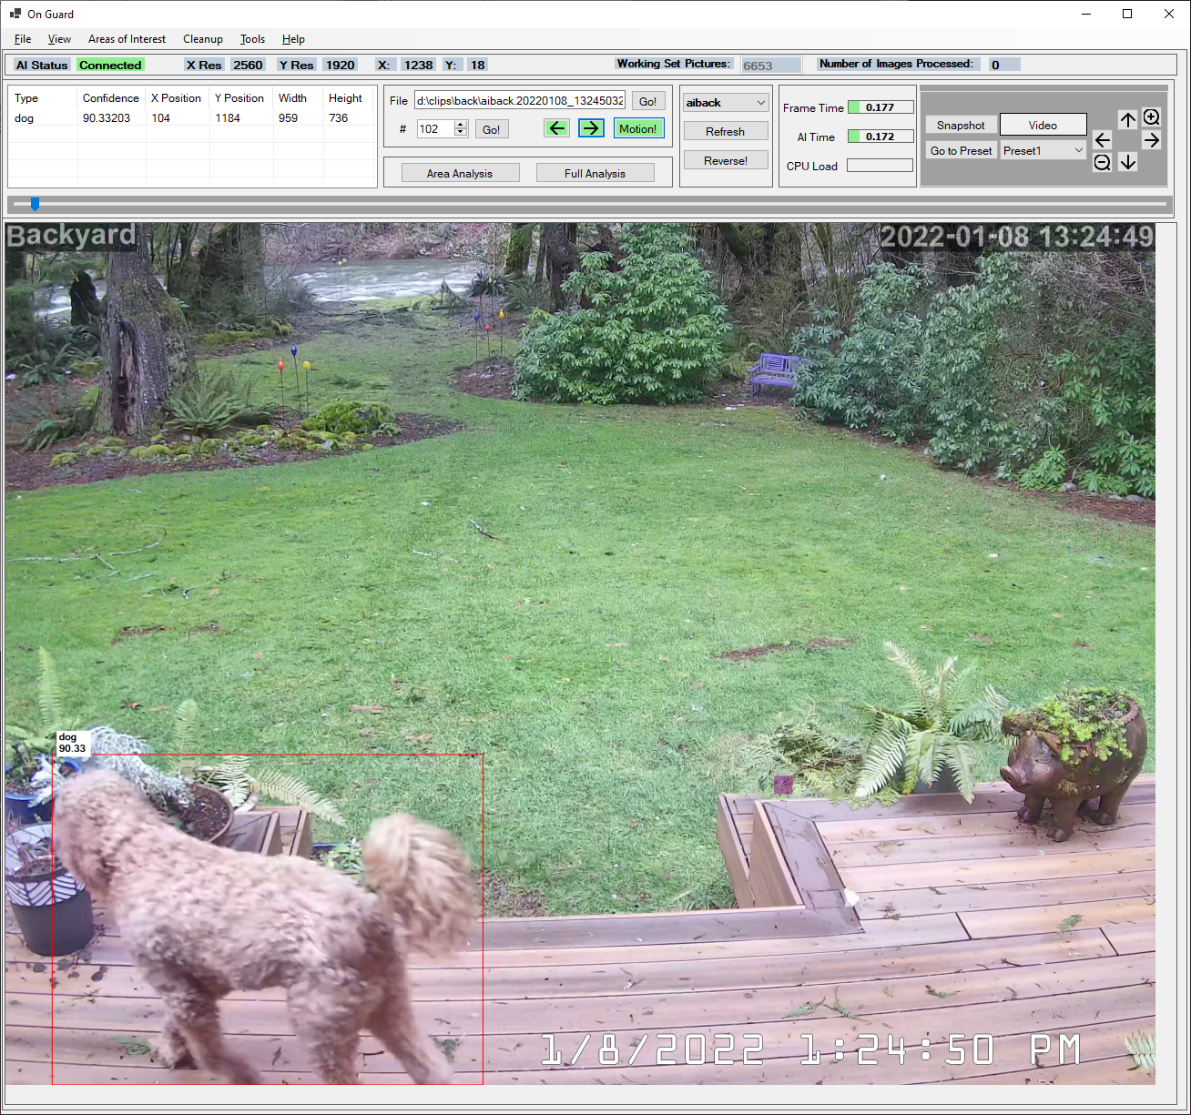

### An Important Concept – The Working Set

On Guard displays a list of images called the “working set”. This is all images for the current camera at the time On Guard starts. You can only update this list by pressing the “Refresh” button. You will **not** see new images taken by the security camera without a refresh or a restart. The purpose of the working set is to allow you to review images and use them to create Areas of Interest. Working with a constantly shifting set of images is just too distracting and is more confusing than it is helpful. If you do wish to see live image press the “Video” button.

## Areas of Interest

Now, comes the useful part. An **Area of Interest** (zone) is defined as a set of small rectangles. These rectangles are in a 64x64 grid on the picture. To start defining an area use the Areas of Interest/Create Area menu item. To add a rectangle, click on the picture with the left mouse button. To delete a rectangle, use the right mouse button. Hold the left or right mouse button and move the mouse to select to draw/erase rectangles.

Defining an area one rectangle at a time can be very tedious. Therefore, you can select how many rectangles are created per mouse click (and move) by using the number keys 1 – 7. For each number the number of rectangles is doubled. Press “2” for 2 rectangles, 4 for 8, 5 for 16, etc. By the time you get to 7 you can select the entire picture with one click. Note that the additional rectangles are down and to the right on the picture. So, even though you press “7” the entire picture will not be selected unless you are clicking in the upper/left corner of the picture.

Note that depending on your picture resolution there may (in somewhat rare cases) be a small area on the bottom of the screen that cannot be selected. This is because there is no guarantee that the vertical resolution can be evenly divided by 64. This will not affect your area definitions/object recognition significantly.

Once you are satisfied that the area covers the area you are interested in press the “F1” key. This is the “I accept the area as shown” button. If you want to cancel the area definition press the “ESC” key. Note that while you are identifying an area all other buttons (right/left/Go To/etc.) are disable as is the main menu. While you are identifying an area the tools area at the bottom of the screen is shown with a dark background indicating that everything there is disabled. Also, the title of the main screen shows you a hint that you may press the Esc, F1, and 1 - 7 keys.

Your area is now identified.

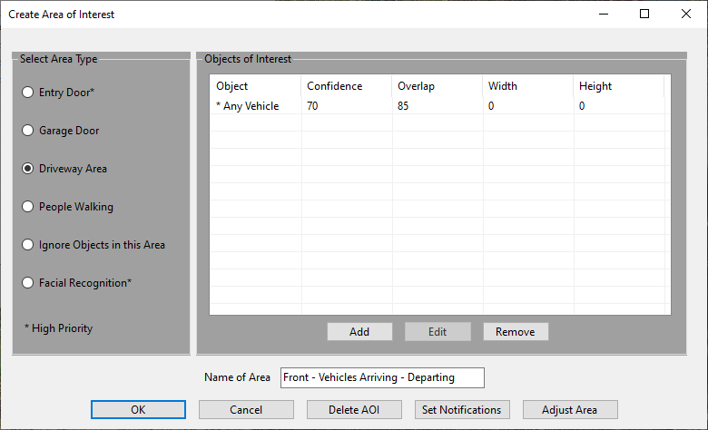

Once your area is defined a dialog box window will appear. This dialog allows you add objects that you are interested in people, cars, trucks, motorcycles, bikes, and/or animals, etc. Specify what type of area this is. Note that **Entry Doors** (Left/Top) are considered a “priority“ area. If you wish to ignore motion in any area, select Ignore Objects. The other options are Driveway, Garage Door, and People Walking. Except for “Doors” and Facial Recognition the area types are only for classification in email messages.

Name the Area of Interest. This name will be displayed in emails for motion events. It is also used for editing an Area of Interest.

You should add it least one recognized object for your area to be useful at all. To add an object of interest, just press the “Add” button you will then see this window.

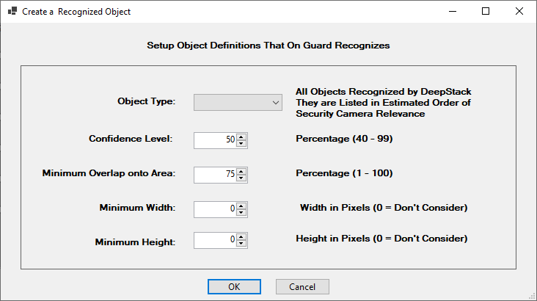

First, use the dropdown to select any object type that DeepStack recognizes. You can add “person”, “bird”, etc.. Note that there are two “special” items. These are “* Any Vehicle” and “* Any Mammal”. “* Any Vehicle” will match cars, trucks, busses, trains, boats, trains, etc.. “* Any Mammal” matches any land animal (except people).

The Confidence box allows you to specify just how certain the AI is about the identification of an object. DeepStack is usually very good about identifying people with a decent range of the camera (Often 90% certain). On the other hand the AI may not be so confident about vehicles. For instance it may know that there was some sort of vehicle movement, but it may not know if the vehicle was a car or truck. You might get a 50% value for a vehicle as a car and a 60% confidence as a truck. In reality there may be a 99% chance that there was some sort of vehicle.

Because of the above described problem in confidence of vehicle type there is a **special rule for vehicles**. Normally On Guard just uses the confidence value returned by DeepStack. However, if there are two (or more) objects identified by DeepStack as any sort of vehicle **and the position of the vehicles overlap by 90%** On Guard fudges these values. On Guard assigns the object type as the object with the highest level confidence (car 66%, truck 52%). In addition, we bump up the priority of the highest confidence by the difference in confidence between the two values. In the case shown we determine that the object is a car, and we bump up the confidence that it is a car by 14 to 84, that is: (66 – 52). Keep this in mind when you enter a confidence level here for any vehicle. This is designed to give you a more realistic confidence setting. Otherwise, for vehicles you may tend to set the confidence levels too low here.

With respect to confidence levels let experience be your guide. You can also use the Analyze button in the UI to help you make those decisions. Keep in mind that the confidence levels at night may be lower than they are during the day.

The Overlap option is very important. For instance, a car/person may be 60% within an area (defined by the overlap of the object rectangle to the area rectangles. The Overlap box allows you to define areas that might be partially in one area and partially within another. This can also be very helpful for two or more areas that may be on top of each other. Again, let experience be your guide.

The Minimum Width and Minimum Height boxes are also very important. The same object closer to a camera will appear larger than those further away. Through creative use of the size values you can obtain a quasi 3D location of an object within the picture. In conjunction with the Overlap value you can usually have a fair degree of certainty whether the object is “interesting” in terms of security. Obviously, there are variations in the size of people and objects, and that will affect the determination of the object’s location.

In the “back deck” picture below the people/animals on the deck will be much larger than the people on the lawn. By defining these sizes you can easily have overlapping Areas. In that example people both on the deck can be in the same picture location close up and in the distance. People further away (smaller) can be ignored while larger pictures of people may trigger an email alert.

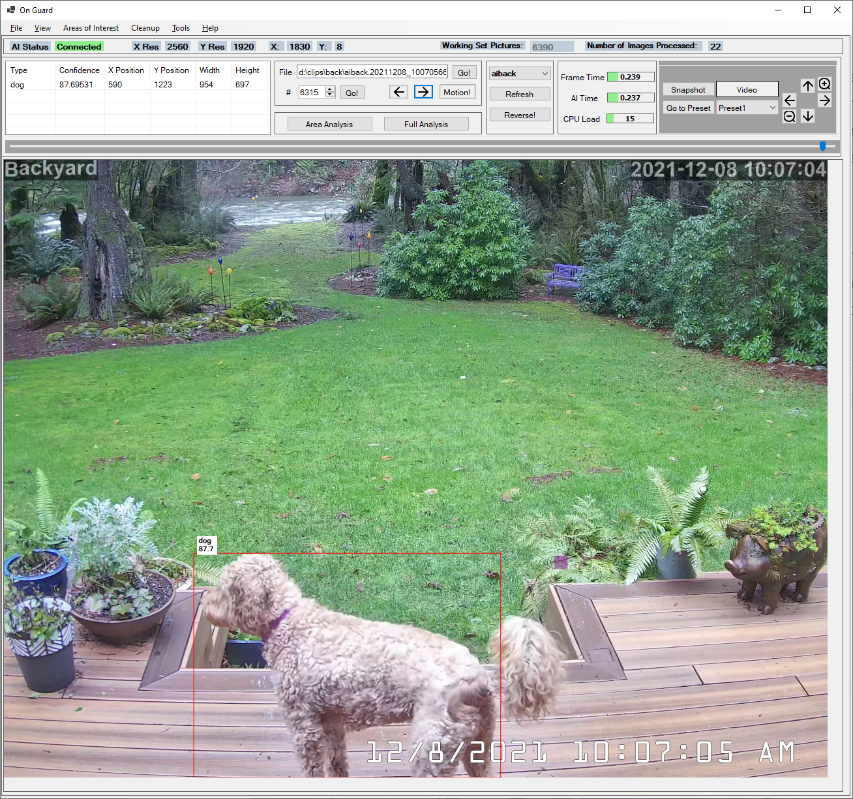

As an aside, note the three decorative glass blubs in the distance/left (near the left big tree trunk). Due to the shape the AI sometimes (not in this picture) thinks that they may be a “person”. However, it generally isn’t too confident that it is a person (say 41% certainty). They are also small/far away, and so aren’t likely to be of interest anyway. The AI is far from perfect, but it is very useful with the proper area definitions.

### Ignoring Objects in an Area

If you decide you want to ignore objects within an area you **still** need to define the **type** of objects you want to ignore in the area. You probably should define percentage overlap for objects in the area. Object size may also play a role in ignoring objects. At a minimum the object type must match for an object to be ignored. Note the “pig planter” in the photo above. At times the AI may think that that planter is a dog (this varies by the picture). So, the “pig” is defined as within an ignore area. It is also defined as type “animal” an overlap of 85%.

The Adjust Area button allows you to go back to the main screen and visually adjust the affected area. Note that once you have accepted the changes (via the F1 key) you will need to use the Edit Areas of Interest menu item to further define options in the area. It does not automatically go back to the area definition screen. Generally it is much easier/faster to make all area definitions first before you adjust the area.

### OK, I’ve Defined an Area – What Now?

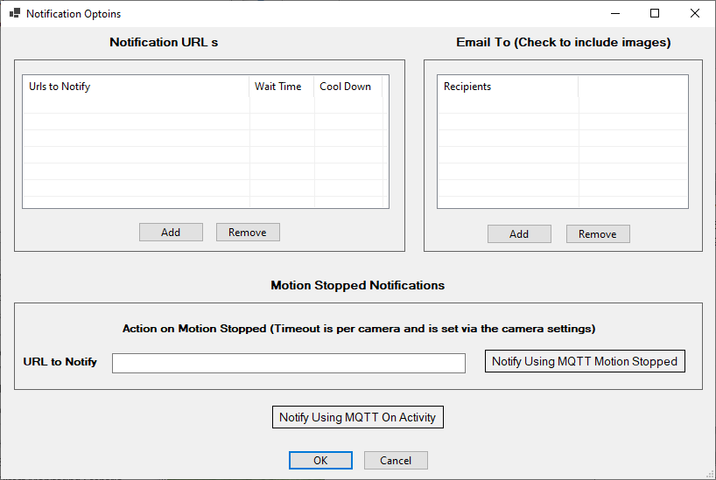

If you haven’t chosen to ignore objects in an area you now need to decide how/if you want to be notified. The two notification primary modes are email and via a message sent to an Internet address. Emails **can include SMS emails/text with pictures sent to your phone, tablet, or computer).** The “Web” address (URL) can be the address of Blue Iris on the same computer. However, there is no restriction on who/where you want notifications “sent” – it is just an address. To define notifications press the “Set Notifications” button.

URL (web addresses) are often used to trigger the Blue Iris camera to start recording. First, press the Notifications button from the Area definition. Then press “Add” under the URLs box. Press “Auto Fill” to trigger the Blue Iris camera. For any other Internet destination “just” enter the URL.

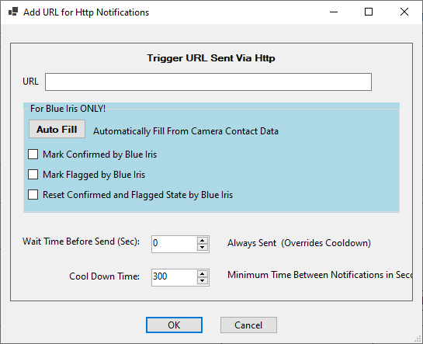

Note the Blue Iris application differentiates between those pictures that have been “Confirmed” and/or “Flagged”. If your notification is for Blue Iris you can optionally set these flags by checking the appropriate box. If desired you can also tell Blue Iris to reset the flags.

For URLs (Interne addresses) you can also enter the “cool down” time between triggers. This limits the number of videos triggered to a reasonable level. Taking too many video hurts nothing except free disk space so this time is defined in seconds.

You can also specify the time (in seconds) to wait before any URL is notified. By adding a delay time between multiple URL notifications you can also order the sequence in which multiple URLs are acted upon. That is: (1) URL #1 occurs with a zero wait time. URL #3 happens after 1 second. URL #2 happens after 5 seconds. The order in which the URLs are added and/or listed does not determine the order the order in which they will be sent. To order URLs in time order you need to add a wait time.

Email notifications are a little more complicated because an email can be intrusive (particularly if it is an SMS/text email address). Therefore, when you define an email address (From Tools/Options/Add Edit Email Addresses) you also specify the time of day, day of week, and cool down time for the camera. You also specify the size of the pictures you want sent with an email. Here in the Notifications, however the only thing you get to select is the pre-defined email address you want notified.

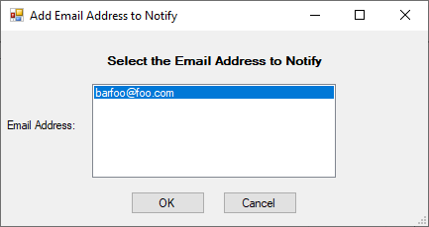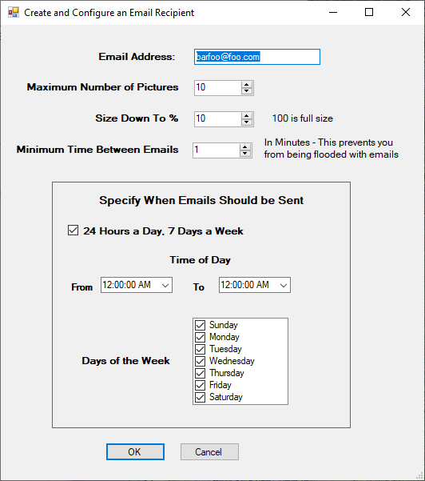

### Getting a Clear Picture of Email Notification/Pictures

In the preceding picture you will see an option for the Email Recipient Maximum Number of Pictures. This is a hard and fast maximum limit on the number of pictures you will see in any email notification. Depending on your Blue Iris settings and the duration of the motion you may see fewer emails. Going back to the Application Settings page you will see other settings that affect the number of pictures.

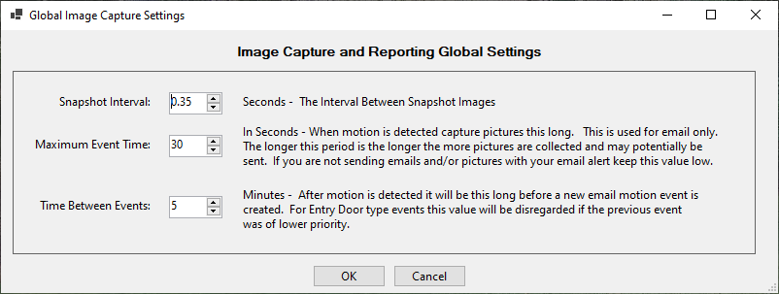

Note the Maximum Event Time setting. This is how long on Guard will wait after the start of the motion to accumulate photos to send. In the example above On Guard will wait 30 seconds (always) before considering an “event” completed. There may be 30 pictures in that interval, there may be only 2.

Once the event completion time expires On Guard will go through all pictures taken in that period. First, it selects “priority” pictures. Priority pictures are those defined as type “Door”. If there are any slots left over in your Maximum Number of Pictures it will then go through the remaining pictures. At this point On Guard selects pictures that have objects (people, etc.) that meet the definitions of other defined areas (such as people in the driveway). Finally, if there are still slots left pictures that fail the previous selection criteria are added. All pictures are shown in time order. So, you may have: 3 pictures of people in the driveway, 2 pictures of people at a door, 4 pictures of people in the driveway, and one picture of someone leaving/not in a defined area.

Another factor to note is that On Guard makes every attempt to avoid bombing you with unwanted email. However, it also doesn’t want to miss an important event. Thus, we need to take a look at the Minimum Time Between Emails setting. Let’s say someone is on the lawn casing the joint. On Guard send an email since she was in an assigned area (Lawn/People Walking). Let’s further say that she decides that it is worth grabbing that nice box on your porch and darts in 10 seconds later. Normally, On Guard would not send a second email since it has only been seconds between the first email set and the motion in the door area. However, since your porch is in a defined door area (People at my door/type Door) things are a bit different. Since the previous email was not defined as Door, and the new motion is in a Door area another email will be sent (with attached pictures). The same thing would **not** occur if the first motion was of type Door, and the second motion is of type People Walking or even of type Door. For example, someone walked in your door, and 50 seconds later people were walking on the lawn another email would not be sent for the lawn event. Therefore, be careful to assign type Door to important/protected areas.

But wait, there’s more! In the Application Settings window there is a setting Time Between Events. This setting is a global interval between “events”, and events can lead to emails. The Minimum Time Between Emails is based on the email recipient. The Time Between events is for all email recipients, and for all areas. However, the exception of “Door” priority events still applies. This is yet another attempt to avoid the email spam problem.

Let’s assume that you want your phone email to be notified rather rarely (say only cars pulling into your driveway, people at your door, an event that only every 20 minutes). However, it may be less intrusive to send an email more often to your home desktop computer. Thus, the Minimum Time Between Emails value may be much higher for the phone. Nevertheless, you really don’t want to come home to 76 emails on your desktop either. Time Between Events setting will prevent this. However, the value shown above (20 minutes) is probably very high in most cases.

## Facial Recognition Areas and Defining Faces

Facial Recognition areas are unique! DeepStack and On Guard does have the capability of defining a special area that can be used to identify individual people. However, first a word of caution. The better full-face view you have on your picture the better the recognition works. It can be difficult to guarantee that a person will be looking directly into a camera from a reasonably close distance! Further, the AI is far from perfect in identifying people, and it is **much** worse if there isn’t a clear image of the face. In most cases this means that your camera must be placed relatively low and directly in front of where people are walking.

To define a Facial Recognition area, start out by selecting this area type. Click the Add button. The face definition is then a 2-step process. In step 1 you define the criteria for identifying a “person”. Like any other area you can select the confidence level and the minimum size, and area overlap.

In step 2 you identify the people you want recognized. Wait! How do you get people in On Guard? The easiest way is to define the face using your camera and On Guard. Simple hold down the **Control** key and press the **right** mouse button! Once you do that a semi-transparent box will pop up. Drag this box over the face of a person you want to define. Re-size the box to cover just their face (not their entire head). Once you are happy with that area press the F1 key to accept that face. You can then name the person. You can repeat this multiple times to get additional samples for the same person.

The face definition pictures are stored in your On Guard data directory under a folder called Faces. Each individual you add has their own folder under that folder. Each person’s folder has one or more pictures of their face in it. Note that this folder is read each time On Guard starts up (not affected by Refresh). You can go into this folder and manually delete/add pictures as desired. In fact, you may want to add people from an ID picture or portrait.

OK, now that you have people to identify let’s go back to where we were before getting sidetracked. You have defined the “person” criteria. You can now add each person you want recognized, along with the confidence level you have that this is the person you care about.

How do we handle “unknown” people? The answer to this is a little complicated. Once we are sure we have a person there are three possible cases. First, we may recognize a person but not recognize any face (hidden, walking away). Second, we may think we recognize someone. Third, we do have a face but it is nobody we know. The confidence level for an “unknown” is set at 50% and cannot be changed (it is ignored).

Be aware that as a person moves, he/she might be recognized in some pictures and not in others. Thus, the finding that we have an unknown person can be suspect. In the future On Guard will be enhanced to look at more that one picture during a set interval to enhance the confidence that we recognize/don’t recognize an individual. This is a little complicated because we could get more than one person in that interval. Also, the “person” identified might change depending on the quality of the image.

For the present time it is suggested that you play with the facial recognition feature **if** it is just being used to capture people walking within an area (due to picture quality issues).

You may wish to use facial recognition to do things like unlock a door automatically for recognized people. If you wish to do this you will need either excellent camera placement **or** you will need to require that these people look directly into the camera from close range. This is certainly worth a try for situations such as a child coming home from school.

## When Motion Stops

When defining notifications for an area you can specify what to do when motion stops. A good example for the need for this is if you want to turn a light on when people are detected and then turn it off afterward.

You can send an URL to a web site and/or you can send an MQTT message. Motion is considered stopped, and motion stopped events are sent when there has been no motion detected for a specified period of time. That period of time is set on a per camera basis since objects may cross multiple areas. If motion happens during that time period then the period is started over and no stopped events are generated. On the other hand, whether or not motions are sent for an area is determined by the area notification options.

Set the time period per camera on the Camera Settings Motion Timeout tab. That period is set in seconds. If you wish to notify a web site via an URL, enter it in the area notifications area. If the URL is completely empty nothing will be sent. If there is anything entered, a web notification will be tried. An invalid web site will result in an error. To send an MQTT message press the notification window button “Notify Using MQTT Motion Stopped” button. It will turn green when MQTT is selected.

# The On Guard Main Window

## Red Rectangles!

Objects that the AI has identified and that On Guard recognizes as potentially of security interest are outline with a red rectangle. The object is also listed in the Objects list in the lower left of the screen. However, this **does not** mean that On Guard considers it to be part of an “Interesting” motion object/event. An Interesting event is one that may trigger a notification that results in a video being recorded or an email notification is sent. In some pictures there may be multiple objects identified by the AI. Some may be interesting, and some may not. If an object is not outlined then the AI has not recognized it, even if you can.

However, there is one criterion for outlining/recognizing objects. Any object type (person/car/etc.) must be defined as interesting at least **one** area for this camera. The reason for this is that the AI itself may recognize **many** objects (flower pots for example) that are not of security interest. If you want the AI to recognize flower pots then you must tell On Guard that by adding that condition to at least one area! This can be confusing because the AI will not outline people until the condition “person” is added somewhere!

## The Picture Timeline

The scroll bar on the right side (light green background) provides the ability to go to a picture taken on a specific date/time. Simply click and hold down the slider button and scroll up and down until you see the date/time you are interested in. Once you let up on the slider the picture will be displayed.

## The Motion Only Button

The Motion Only button allows you to go from one picture in which interesting motion has been detected to the next picture with such motion. This can bypass hundreds or thousands of pictures in which no interesting motion has been detected.

**BUT! …** The Motion Only button only recognizes motion that has been detected while On Guard was running. This is because as new motion is recognized the name of the picture is stored in a database. If On Guard wasn’t running it couldn’t add those pictures to the database. **BUT!....** you can manually scan through all available pictures for a camera and sync the pictures up with the motion database. This is available from the Cleanup/Sync Motion to Database menu option.

If you delete pictures in your camera directory (via Blue Iris, or manually) the database has no way of knowing this. Therefore, the pictures may be gone but still in the motion database. If On Guard tries to go to the next interesting picture (the Motion Only button is down) and can’t it find that picture, then the picture name will be deleted from the database. This all happens behind the scenes, so you won’t normally notice this if there are only a few pictures missing/deleted. However, if a lot of pictures have been deleted, the movement forward or backward may be slowed as the missing pictures are removed from the database.

## The Area Analyze Button

If you are defining a complicated series of areas it may not always be clear why On Guard chooses to define an event as “interesting”, or not. Go to the picture in question using any of the navigation buttons, and then press Analyze It button. See a sample analysis below. Note that On Guard goes through each area defined (there are a number). It shows the result (someone walking in the distance). It also lists the reason another area wasn’t selected. It shows the object type mismatches (person vs. car/truck/etc.).

This is an essential tool in defining your areas. Note (not shown) that the determination of whether or not to send an email vs. just recording a video depends on the area this person is in. Since he is a person in the distance an email is not sent. However, a video recording is started.

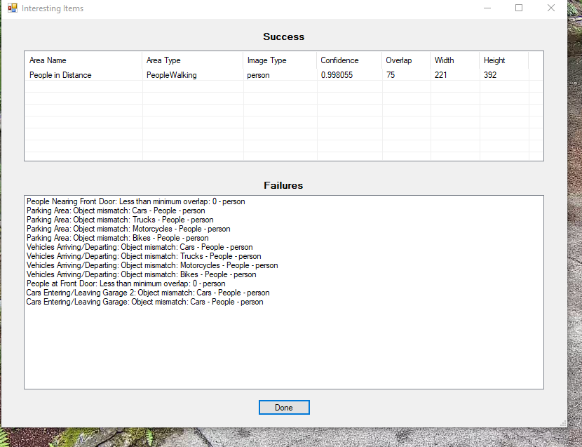

Let’s look at another case:

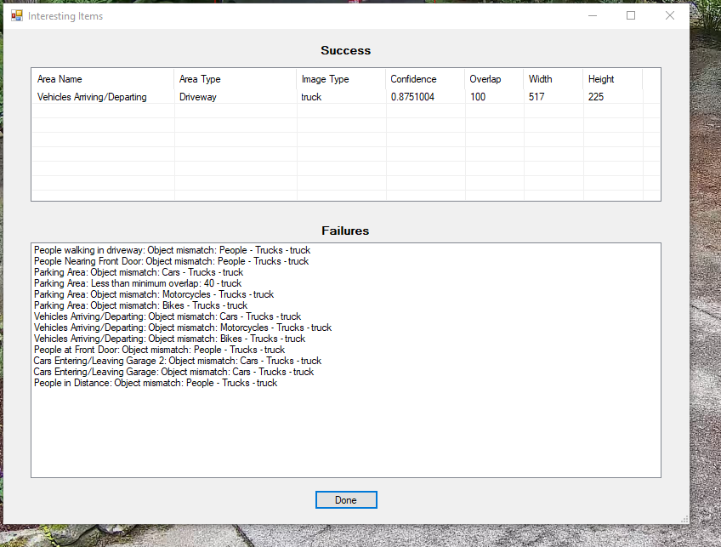

In this case the identified truck (we are 87% certain it is a truck) is in the Driveway and in an area defined as Vehicles Arriving/Departing. It is not in the parking area with only a 40% overlap. If it were in the parking area we’d ignore it.

Note that there often many reasons why an event is not interesting (worthy of a notification). First, the AI may not have identified it. The AI may not have enough confidence. The object overlap may not be as high as the area requires. Areas defined as “Ignored” are a special case. First, the object found is analyzed. During the first pass of analysis it may “pass” all requirements. Then, there is a second pass to compare the object overlaps to any ignored areas. If the object is then found to overlap the ignored area by the percentage required and it is of the correct type, the object is ignored.

If you click the “**Full Analysis**” button On Guard will analyze every possible object that DeepStack recognizes. This may include things like flower pots! Still, it can be useful in situations where you don’t understand why On Guard doesn’t consider a picture interesting.

## Boxes and More Boxes!

Moving back to the main screen ---- In the bottom left of the main screen there will be a list of all objects the AI has identified on this stored picture. This includes the size and position of the objects. You can use see the AI’s confidence that it is correct in identifying the object. The size information can help you set the minimum size of objects in the Area of Interest dialog. In the sample picture below there is one object of type “dog”. The AI is 98% certain it is a dog (although sometimes the AI thinks she is a “sheep”, and who can blame it really).

## Viewing stored pictures

At the bottom/center of the screen you are given a variety of ways to navigate to stored pictures. This includes Forward/Back, Go To a specific picture file name, and Go To a file number (in the working set list). The default list of pictures is presented in most recent to oldest order by default. If you want to change that press the “Reverse” button.

## Viewing Live Camera Pictures/Video

The bottom/right of the screen allows you to look at live or snapshot views from the camera. The Snapshot” button is self-explanatory. It asks the camera for a snapshot of live data. Note that it does not save the snapshot to your disk.

The “Video” button will feed you a live stream from the camera. Note that this video will be a bit jerky. It also causes a fair amount of network “traffic” since there is no data compression (other than .jpg compression) used. There has been no attempt to optimize this video feed since it is intended for occasional use and not long-term viewing.

There are also arrow buttons to move Pan/Tilt cameras and Zoom cameras with that capability. You can also press the “Go to Preset” button will allow you to move to camera preset position (also depending on camera capability). Note that the Preset button waits five seconds before displaying another “live” image. This is to give the camera time to move to the preset. This may not be enough for all cameras and all positions. You can turn on the Video button to monitor the camera as it moves to another position.

## Camera Selection

You may have multiple cameras. However, you can only see pictures from one camera at a time. The pictures displayed are there for the primary purpose of creating Areas of Interest. If you want an application that can display multiple cameras at once, please use Blue Iris or iSpy. Note that you can select the current camera from two places. The first is under Tools/Camera Settings. That selection is “sticky” in that it is kept when you restart the application. The more convenient method is by selecting the camera from the dropdown box at the bottom mid-right of the screen.

## Computer Digestive Problems

The current CPU/computer load is shown near the camera selection drop down. If you are running the DeepStack application on this computer it is important to note the CPU load when there is continuous motion. When processing using the CPU mode rather than GPU mode the CPU load will often spike to 100% (all red) while there is motion, and maybe for a while (maybe much longer than a while). Motion frames are kept in a queue/list. They are parceled out to the DeepStack AI as CPU resources are available. This is done to make sure that your computer is not so overloaded that it becomes non-responsive.

A backlog in processing by DeepStack may mean that On Guard may trigger video recording via Blue Iris so that your video clip will start “late”. Therefore, you may also wish to set the Blue Iris pre-trigger video buffer (Blue Iris - Camera Settings/Record tab) to something in the range of 10 to 30 seconds. This enables Blue Iris to look back to a time before it told by On Guard to start recording. This will almost always allow you to see video of the event that triggered the video.

### Frame Time/AI Time

The **total** time it took to process the last frame through the AI detection process is shown in the Frame Time box. The colored bar in the box is a proportion up to 1 second. The processing time is shown in the text. Note that this time source is for **all** cameras. It comes from both background processing and processing when scrolling through pictures in the working set. Note that while processing times of .75 seconds or more are shown in red, that isn’t necessarily bad. It really depends on how many frames per second you are capturing, and how long motion continues. If your processing time routinely far exceed your picture capture time, and you have frequent or constant motion, that can be bad as things will get very backed up. On the other hand, if your capture interval is 1 second, processing time is 1.75 seconds and you typically have motion for 30 seconds to a minute that is perfectly fine.

There is a second bar that shows the AI Time. This is the time starting with the request from On Guard to the time it receives a response back from DeepStack. This is usually shorter than the Frame Time because the Frame Time includes the total time from the point where On Guard starts processing the picture to the time it gets back. The Frame Time may include a significant wait before On Guard is able to dispatch the picture to DeepStack. Only 4 outstanding requests to DeepStack are allowed at a time. So, you may see an entirely reasonable AI time but an overall miserable Frame Time.

## Cleanup of Old Pictures

Motion in front of your cameras may result in an accumulation of a **lot** of old pictures, particularly outdoors. These can consume significant disk space. The Cleanup/Cleanup Old Pictures menu item will allow you to delete pictures before the specified time interval. You can decide whether your want to delete pictures from all camera or just the current camera. You can also choose whether to keep only pictures previously identified as having interesting movement.

On Guard does not automatically cleanup old pictures because these may provide a good backup of important motion events. However, Blue Iris can/may delete them depending on how it is configured. It can, in fact, be less that straight forward preventing Blue Iris from doing so.

Please be aware that some anti-virus software may prevent On Guard from deleting pictures. Your anti-virus software should have a means of excluding On Guard from this protection feature. Also, note that you may need to re-do this exclusion if/when On Guard changes version number or gets reinstalled.

While you can delete unwanted pictures using Windows, it is suggested that you do so via On Guard so that the motion database is in sync with the pictures in your working set.

## Information at the Top of the Screen

At the top of the screen, you should see the following. The “Working Set Pictures” is the number of pictures you can select from with the navigate buttons. This number does **not** change even if there is motion detected. Pressing the bottom “Refresh” button will load any new pictures into the working set.

The top also shows the X and Y location of the mouse cursor. Note that this is in picture/pixel coordinates. This is not the relative mouse position on your screen. Depending on the resolution of your camera you may see the mouse positions number jump no matter how careful you are in moving the mouse.

The Number of Pictures Processed keeps a running count of the images processed by On Guard since you started it. If this number seems excessive you may want to check the detection sensitivity of the camera or Blue Iris motion detection properties. Outdoor cameras tend to have a large number of images because lighting conditions changes may result in “motion”. Also, rain, snow, and bugs can cause motion to be detected.

You will also see the rather cryptic areas labeled X Res and Y Res. This is the number of pixels in width and height contained in the picture. This is not the width and height of the image displayed on your screen. It is used for reference purposes. Note that the Test Image photos will not have the same width and height as your normal camera pictures. On Guard does not care about the width and height of the picture.

## The View Menu

Under the Show menu there are 3 options. Show Object Rectangles turns on/off processing of pictures through the AI. Because the AI can be slow, moving through stored pictures can be slow as well. Turning off Show Object Rectangles is a good way to look through pictures until you see something interesting. Then turn on Show Object Rectangles to see if the AI can recognize anything. You can use the control + “s” key as a shortcut to this menu option. Note that with Show Object Rectangles option on that you can experience the CPU use/DeepStack processing time for just one picture by moving forward/backward within the picture working set.

Show Areas of Interest turn on and off the display of areas you’ve defined. Seeing these areas can be important when tuning On Guard to report/record things of interest to you. However, it can also be annoying because these areas partially obscure the pictures. Turn it on and off via the menu. Note the number of areas in the picture below.

.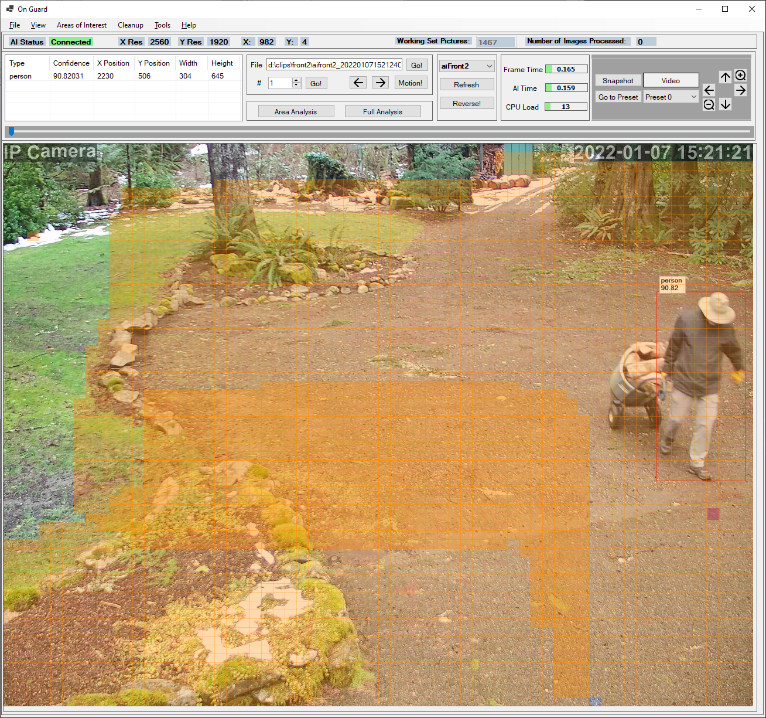 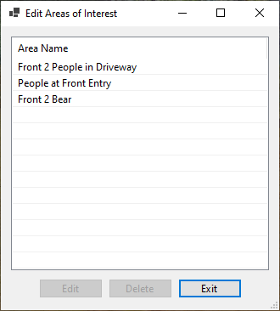

### Picture Display Options

Often/usually pictures taken by modern high resolution cameras will not fit completely within the On Guard main picture frame at their original resolution. On Guard provides you with four options for displaying pictures to match your preferences:

1. Fill Horizontally. The picture will fill the entire available horizonal area. If necessary, the picture is reduced (or rarely expanded) to fit this area. The vertical region is set to maintain the aspect ratio of the picture. The picture will not be stretched. However, you may need to use scroll bars to see all of the picture at the top or bottom. This option (and option 2) will provide the most visual detail if you maximize On Guard.
2. Fill Vertically. The picture will fill the entire vertical area. This is very similar to option 1 except that you may need to scroll the picture horizontally to see the entire picture. The picture is not stretched.
3. Fill Horizontally and Vertically. The picture will always fill the entire available area. There are never scroll bars. However, in order to do this the picture may be significantly stretched/distorted depending on how you size your window.
4. Use the set picture size of 1280x960 pixels. This matches the area of the tool area at the top of the screen and is a good match for many high resolution monitors. If you maximize your window you will typically see a large unfilled area to the right and bottom of the picture. If you resize the picture smaller than the default you may need both vertical and horizontal scroll bars. If you don’t shrink the window below the default you should be able to see the entire tool bar area without scrolling it.

## The Tools Menu

The Tools menu contains the various application related settings. These include Application Settings, Camera Settings, Email Server Settings, Email Addresses, and MQTT Settings, and more. The selection you will probably use most the Camera Settings. The Camera Settings will be explained in more detail later.

### MQTT

MQTT is a means of communication used by many Internet of Things devices. MQTT can be used for such things as turning on a light when motion is detected. On Guard now supports the publishing of motion events to MQTT. Events are published in the format that you define. There is a list of tags surrounded by braces {}. The application will fill in the value for the tag. For instance, the tag {File} will be substituted with the image file name that generated a motion related event. The content of that publication is the file name of the picture triggering the alert.

In order to use MQTT you must first setup the MQTT server address and port. Optionally, you can enter your MQTT user name and password. You can also specify whether the published event will sent to the server via a secure (TLS) link. You either define the topic names and payloads that you want sent or you can just leave the default topics and payloads. Note that anything other than pre-defined tags will be sent exactly as you enter it.

For each area that you want to publish an MQTT event, you must set a flag (button) in the area of interest Notifications page. If the MQTT button is green for that area an MQTT event will be published if you have also setup MQTT under the tools menu.

If you don’t know what MQTT is, don’t worry. It is strictly optional. However, it can’t hurt to do a Google search and find out about it.

### Analysis Settings

Under the Analysis Settings menu item you are given options regarding how On Guard (**not** DeepStack) analyzes images. Some of these settings (regarding vehicles) are discussed in other sections below. It is anticipated that additional options will be added over time.

### AI Alert Settings

At times the DeepStack AI may die unexpectedly. If you are not aware that it has died you may go on expecting On Guard to work properly indefinitely when in fact it is doing nothing. Using this menu option you can set how/if you want to be notified when the AI stops responding. You can select to be notified via one email address and/or via MQTT. If you select MQTT you may define the Topic and Payload of the message.

### Test Images

Clicking the Test Image menu will cause a series of photos embedded in the application to be sent to the camera directory for all cameras. These images are somewhat random (public domain/internet), and may include people and/or vehicles. This feature helps ensure that On Guard is working properly. If you have areas defined it is more than likely that at one or more of these images will trigger any notifications you’ve defined for your areas.

Note that you can always feel free to use Windows to drag and drop pictures into your camera directories. The only limitation is that these pictures must start with your camera prefix for the camera to recognize it. This just automates the process.

Note that you can get rid of these pictures (and all your others) by using the Cleanup button with a time of zero days and zero hours.

## Special Notes on Object Recognition/Vehicles

Parked vehicles are by default no longer considered objects when determining motion. For instance, if a car is parked in a driveway and a cat wanders by causing Blue Iris to trigger a series of motion pictures, the car will be filtered out. If you were looking for cats then you would get a notification. If you were looking for cars you won’t. They will still be shown as objects in the image review screen of the main window.

You can change this behavior by settings in the Tools/Analysis Settings menu. There are two methods used for deciding if a car is parked. The first method is the overlap of a vehicle on a vehicle in a preceding picture. The second method checks the corners of these two vehicles. This is used because someone (or an animal) stepping in front of a vehicle corner may dramatically change the outline of a vehicle. You can opt out using either or both of these methods using that menu item. The “corners” method is considered slightly less reliable.

On a different but related matter, occasionally DeepStack might not be sure what type of vehicle you are seeing. You might get 2 (possibly more) outlines around on real life vehicle. It might be considered both a car, a truck, and possibly a bus. All the outlines for these objects might differ slightly. They might all have different confidence levels.

In these cases we now attempt to consider these DeepStack objects as one object (based on the overlap between them). We now select the object type with the highest confidence level. In addition, since DeepStack might not have been sure what **kind** of vehicle it was seeing so the confidence level of any one interpretation is artificially low. Therefore, the On Guard the confidence level of the selected vehicles is bumped. Note that this may create problems when multiple vehicles are close together and the camera angle is “just right”.

You can opt out on the artificial confidence boost using the Tools/Analysis menu and the “Increase Confidence in Multi-Vehicle Overlapping Definitions” checkmark.

## Help/About

Under the Help/About menu you can find the all-important picture of the fierce mascot of On Guard standing guard over her domain! There is also the obligatory license verbiage. The application is free, but for your personal or small business use. Use it at your own risk too. The license terms may become less restrictive as the project matures.

## Help/Log File

On Guard logs activity and errors to a file called "OnGuard.txt.". When you select Help/Log File an **external** application will be launched to display this file. The specific application that will display your log file is dependent on the application you have set in Windows to display “.txt” files. By default this is Notepad. Note that this file is not update in real time. To see any changes you will need to close the file and re-open it.

### Help/Log Detailed Information

By clicking this menu item you turn on/off the collection of **detailed** log information. All detailed entries (those that normally are not saved) are preceded by: (Trace). This detailed information may help in tracking down hard to find problems with On Guard or with your area definitions. However, the amount of detail provided may be annoying.

### Help/Delete Log File

The log file can get quite large over time. Detailed information makes it grow even faster. This menu item allows you to delete the log file. The deletion is tried up to 5 times. If the log file is in heavy use this may fail. Just try again later when things have settled down.

## Help! Where Did On Guard Go?

Let’s face it. Once you get On Guard up and running you often really don’t want it cluttering up your Windows task bar or your screen. Normally, all active Windows applications are shown in the task bar. When you minimize On Guard it hides itself. It may look like On Guard has crashed (that never happens)! Instead a (very small and difficult to recognize) icon shows up in your System Tray (in the general vicinity of the clock). To restore On Guard double click the icon. BTW, anyone interested may contribute a better icon, and it will be gladly accepted. The disadvantage of relocating the icon to the system tray is that there are often more icons in the tray that can be shown at once. You may need to open up the tray to see it by clicking the “^” or “<” button in the system tray to see On Guard listed.

## Turning Lights (and other things) On and Off

### MQTT

There are a variety of options for using detected motion to turn lights (or any other “smart” devices) on and off. First, go to the area Notification Options screen. If you have devices that are MQTT compatible, you can simply press the Notify Using MQTT on Activity button. To turn the device off when motion stops (set at the Camera Settings screen) press the Notify Using MQTT Motion Stopped button.

You can also turn devices on and off using HTTP/URL notifications. Just enter your URL in the appropriate boxes. Sounds easy! The question now becomes, what URLs should you use? Try IFTTT.

### IFTTT (If This Then That)

IFTTT is a very popular and widely supported web utility that can be found at IFTTT.com. Unfortunately it is not quite as easy as MQTT. Many inexpensive light switches are IFTTT compatible. Further, Alexa is IFTTT compatible. A variety of switches can be found in the $15 - $50 price range. Just try an Amazon search for IFTTT switch. It is beyond the scope of this document to fully describe getting setup with IFTTT, but here are some hints that worked as of 1/2022.

The first thing you need to do is setup an IFTTT account. Add your device/switch by brand or in accordance with the device instructions. Now comes the considerably less than obvious steps. To turn a device on/off or otherwise trigger a device you need to create a service of type “Webhooks”.

1. Click “Create” to create an action. It will bring up: “**IF** This (Add)”.
2. Click “Add”. It will bring up a set of icons for actions.
3. Type “Webhooks” in the search bar that comes up next.
4. Click on the “Webhooks” Icon.
5. Click “Receive a Web Request”
6. Give your Event a name.
7. Click “Create Trigger”
8. Select the device and device action you want (in my case SmartLife (the switch device name)) plus, “Turn On” – The action I wanted to happen.). Let there be light!
9. Click “Continue”
10. Click “Finish”
11. Go to “Home”, then “My Services” under your account (the head icon)
12. In the “My Services” scroll down to “Webhooks” and click on it.
13. Click “Settings” for “Webhooks” (gear icon)
14. You will see a section called “URL”. Copy the section of the URL after “use/” (apparently random characters, but they aren’t). This is your secret key. Keep it for use with other URLs! It does not change.
15. Create your URL. It will look something like: [**https://maker.ifttt.com/trigger/YourActionNameGoesHere/with/key**/**b4VKRYk3GOkabcdefghijk**](https://maker.ifttt.com/trigger/YourActionNameGoesHere/with/key/b4VKRYk3GOkabcdefghijk). The **red part** up to “trigger/” and “/with/key/” is always the same. Substitute **your action name in the green part, and the secret key you copied in place of the stuff after** “**key/**”.

Yes, that could be much, much easier. However, **after** the first time (and you have save your secret key) it actually goes reasonably fast (5 – 10 minutes or less, guaranteed).

# Appendices

## Thanks To:

This application was inspired by Gentle Pumpkin and his work “Free AI Person Detection for Blue Iris” at <https://ipcamtalk.com/threads/tool-tutorial-free-ai-person-detection-for-blue-iris.37330/>. On Guard has taken his basic idea of using Blue Iris and DeepStack to enhance security camera results. On Guard offers some enhancements. Gentle Pumpkin offers some features On Guard does not. Again, thanks!

## Setting Up Blue Iris for Use with On Guard

The use of Blue Iris with On Guard is now strictly optional! While On Guard was originally designed to work with Blue Iris this requirement is now **completely** gone with Version 3.0. However, there are several settings that can be used to implement the Blue Iris/On Guard combination. Please note that Blue Iris is a valuable tool. For one thing, On Guard can easily be setup to trigger Blue Iris video recording. Yes, Blue Iris does now allow use of the DeepStack AI. However, it is fondly believed that On Guard allows much more flexibility in detecting appropriate motion. Also, Blue Iris is **not** free (with updates and support). There is an annual fee.

### A Note on the Need for a Second Hidden/Virtual Camera in Blue Iris

The original “Free AI Person Detection for Blue Iris” tool referenced above required the use of a second Blue Iris virtual/normally hidden camera (not an actual physical camera) to generate still .jpg pictures for use in triggering a second camera that takes the actual video. That tool has migrated away from that mode so that only one camera need be setup.

On Guard was a spinoff from the AI Tool, so in part the use of a second virtual camera on Blue Iris was related to the original concept. However, at this point there are no plans to migrate to any other model, and a second camera will be required in Blue Iris for the foreseeable future.

There are good reasons for maintaining the second camera model. The primary reason is that On Guard is compatible with **any** IP/network camera that can directly or indirectly output still images to a directory. Blue Iris is **not** required. This includes any camera that can output motion files via FTP. Almost any decent IP/network camera made in the last 5+ years or so can do that with the proper setup. Don’t get me wrong. Blue Iris is a great tool!

The second major reason is that On Guard operates on a different theory. Its job is **not** just to trigger video. While it can optionally do that, it is used to capture and display motion related **still** image file.

Finally, On Guard was designed from the ground up to allow for the easy definition of Areas of Interest (zones). As you layout a zone, you need the history of recently captured images to compare those images to that zone. You can look at a picture and say “yeah, that should have triggered a recording, why didn’t it”. Using the Analyze Area button you can tell exactly why it did or didn’t on any one frame. You can then easily adjust your area settings.

### Setup Steps

1. Setup Blue Iris and open it in Administrative Settings. Ensure that videos are recorded when motion occurs just to double check everything. Make sure you get/set your Blue Iris user name and password while you’re at it.
2. **Create or find an 'Input Path' folder:**​ We need one or more directories where Blue Iris stores the images. You can add a path to Blue Iris by opening the settings of Blue Iris, then 'Clips and archiving', then click on one of aux folders in the list on the left (if desired you can change the folder name by clicking the right side of the name). Then create a new folder. Set your AuxX (or renamed) folder to this new folder location.
3. **Enable URL triggering feature in Blue Iris**​: This is the method we use to trigger a video clip when an interesting event occurs. URL triggering is disabled by default, so to be able to trigger a camera in Blue Iris via URL, you **must** do the following in Blue Iris main settings page (not the camera page!). (1) Go to Setting->Webserver->Advanced and **disable** 'use secure session keys and login page'.​ (2): Go to Settings->Users and enter and select a user and copy the password, or create a new administrator user. The credentials will be later to make the trigger URL.​
4. **Duplicate a camera**​: Now we have to create a camera **duplicate** whose only purpose is to save images when a motion is detected. Add a new camera, give it a name that makes sense (e.g. if your original camera was called 'frontyard', call it 'aifrontyard'), and in the **Type** section select 'copy from another camera' and choose the source camera (the camera you want triggered).​
5. On the **duplicate** camera **Record** tab (1) Check only the JPEGS checkbox and “use default” boxes. Uncheck everything else. (2) Set the record condition to “**When Triggered**”. (3) Next to where it says “each mm:ss.s there is an entry for the time between pictures. It is suggested that you start with a value of “1.0”, one picture each second. (4) Change the Quality (%) entry to something reasonable. 100% can create fairly large pictures for not much gain. Try a value of 85. (5) Change the output directory to one of the directories you set in step 2.
6. On the **duplicate** camera **Trigger** tab (1) Check only the “Motion sensor” box. Uncheck everything else. (2) Under “Break time” enter how long you wish pictures to be recorded in “End trigger …”. This time divided by the time between pictures controls the minimum number of pictures that will be taken. You should also have the value under “Maximum trigger …” set to about 60 seconds. You can always adjust these values later. (3) next to “Motion sensor” there is a “Configure” button. Click it. On the “Motion sensor” popup uncheck everything except “Object detection”. **Later** you will probably want to go back here and adjust the values for “Min. object size”, “Min. contrast”, and “Min. duration” to make sure that you don’t get too many false pictures, but don’t miss important pictures either.
7. On the **duplicate** camera **General** tab (1) Give the camera a “short” name and a “name”. To keep it simple, make these the same. It is suggested that you preface these names with “ai” to differentiate them from the original (target) camera. (2) You may eventually wish to check the “Hidden” box so that the duplicate doesn’t show up in you display. For now, leave this unchecked. (3) Don’t make any other changes.
8. Disable motion detection for **original** camera**:** Disable motion detection and other triggers on the original camera ('frontyard'), so that nothing except On Guard triggers the original camera. To do that open the camera settings of our original camera, go to 'Trigger' and uncheck all boxes in the 'Sources' area.​ It is also suggested that you check the box for “pre-trigger buffer” and enter at least 5 seconds. This will ensure that you see the beginning of the motion if On Guard is backed up processing images.

## Installation Note (Database/.NET Core)

As of version 1.1 On Guard installs a database service from Microsoft called “LocalDB”. This provides support for storing the list of interesting/motion related pictures. Therefore, you may notice database (SQL) support being added as a part of the installation process during setup. It is normal, and nothing to worry about. All files are stored locally. Nothing is ever **sent** over the Internet. That said, Setup does use the Internet to **download** the necessary support files.

On Guard 3.0 uses Microsoft .NET 6.0. .NET 6.0 is new as of 1/2022. Most users **will** need to install that feature. This is done automatically as a part of the Setup application. However, it does take some time and will probably re-direct you to the Microsoft web site and/or ask permission to install this.

## Using localhost

In several of the settings for On Guard the default address for your local PC will be shown as “localhost”. This is appropriate for only devices on your PC. However, there have been reports that “localhost” does not work with **some** On Guard computers. If “localhost” does not work it is suggested that you try using an IP address of “127.0.0.1” (no quotes). If that still does not work you may need to use the IP (V4) address of your computer. This can be found in several spots in Windows. One of the easiest is to type “cmd” from your Windows Start Menu. Then, type “ipconfig” (no quotes, plus return). You will see a listing that may be somewhat cryptic you should see something that says something like: (IPv4 Address. . . . . . . . . . . : **192.168.0.2**) . That numeric part with dots should be the local address of your machine. You can use that in place of localhost wherever you find it. Note that you **do not** use anything ending with “.1” like: 192.168.0.**1** because that refers to your local router. Also, note that the address of your computer does not necessarily start with “192.”, but it **often** does on home devices.

Your default camera IP Address is also shown as “localhost”. This is only appropriate for software such as Blue Iris running on the same computer as On Guard. It is **not** correct for external cameras that you access directly. For those cameras you will need the IP Address of that camera.

## Bugs and Feature Requests

Yes, there are bugs! Hopefully it works well enough to be useful. Please report bugs via Github or the IPCamTalk page for On Guard 3.0. The more community interest there is the more likely it is that bugs will be fixed and features added. On Guard does not charge for the application or support. There is no paid advertising. Bugs will be fixed as time is available, but please be understanding.